Report for: | TRAFFIC & ROAD SAFETY ADVISORY PANEL
Date of Meeting: | 9 November 2022
Subject: | Marlborough School Streets Update
Key Decision: | No
Responsible Officer: | Tony Galloway – Interim Director of Environmental Services
Portfolio Holder: | Councillor Anjana Patel – Portfolio Holder for Environment and Community Safety
Exempt: | No
Decision subject to Call-in: | No
Wards affected: | Marlborough
Enclosures: | Appendix A – Consultation results  Appendix B – Consultation document

Section 1 – Summary and Recommendations

Recommendation:

That the Panel note the contents of the report and recommend to the Portfolio Holder for Environment and Community Safety that the Marlborough School Streets Scheme be deleted.

Reason: (For recommendation)

The consultation responses and feedback received to the scheme indicate that it was not supported and should be removed.

Section 2 – Report

2 Introduction

- This report provides Members with an update on the Marlborough School Streets Scheme consultation of 21 July 2022 to 9 October 2022 and the outcome of that consultation.

- The consultation was originally scheduled to run from 21 July 2022 to 25 September, however, due to the Queen’s passing, some engagement sessions were rescheduled and therefore the consultation was extended to 9 October 2022. The engagement sessions were held as follows:

- Wednesday 10 August, 4pm to 7pm Marlborough School
- Saturday 20 August, 10am to 1pm Civic Centre
- Saturday 10 September, 10am to 1pm Marlborough School (rescheduled due to Queen’s passing)
- Thursday 15 September, 4pm to 7pm Civic Centre (rescheduled due to Queens passing)
- Saturday 24 September, 10am to 1pm Marlborough School
- Wednesday 28 September, 4pm to 7pm, Civic Centre

- In addition, the Council held a coffee morning at the school for parents / carers and teachers on Friday 23 September 9-10am at Marlborough School.

- A copy of the consultation documentation can be found at Appendix B.

- The consultation offered three scenarios as an outcome to the consultation:

- remove the scheme in its entirety,
- amend the schemes with fewer hours of control and add in unpaid carers to the exemption of the scheme, or
- keep the scheme as it is.

- Furthermore, the council asked for any other comments or ideas on how the scheme may be amended.

Background

  - Marlborough School Street was originally implemented under an experimental Traffic Order following the government’s statutory guidance under Section 18 of the Traffic Management Act 2004 to all highways authorities in England to take measures to reallocate road space to people walking and cycling to encourage active travel and social distance during the Covid pandemic.

  - The School Street was made permanent in March 2022 after an 18-month experimental period.

  - Following many complaints from residents, since the implementation of the scheme, the Council decided to reconsult on the scheme to check residents still wanted the scheme.

Consultation results

  - The consultation ran from 21 July 2022 to 9 October 2022.

  - The feedback from the consultation was as follows

  - The Council consulted 3,000 households for this scheme and had a total response rate of 210. This is a response rate of 7%.

  - Of the 210 responses they advised

- 66% of respondents (139/210) said they lived within the school scheme, or on surrounding roads
- 16% of respondents (34/210) said they had children at the school
- Less than 1% of respondents (2/207) work at the school.
- 3% of respondents (7/207) admitted that they commute through the area.

- 62% of all responses (131/210) said they did not wish the scheme to continue
- 86% of respondents who either live on the school street, or the surrounding roads (120/139), said they did not wish the scheme to continue
- 41% of those who have children at the school, or work at the school (15/36) would like the scheme to be removed.

- 47% (99/210) said there were fewer cars during the scheme times but 29% felt there were the same.
- 49% (102/210) felt there were more cars on surrounding roads but 31% (64/210) felt there were the same.
- 60% (128/210) felt parking and congestion was worse on other roads since the scheme was implemented.

  - These are the key responses, all other responses can be seen at Appendix A.
  - Normally a seven percent response rate would be too low to make a recommendation, however, based on the clear strong feelings of the residents and businesses, a recommendation is being made on this occasion.

  - The feedback from the engagement sessions has been summarised as follows:

- Opposition to the scheme, wanting it removed completely
- Issues with obtaining permits
- Communication difficulties with Council
- Delivery problems during scheme hours
- Displacement of cars onto other roads
- Parking behavioural issues, including blocking driveways
- Personal difficulties in emergencies due to restrictions

- Officer comments and recommendations

  - Based on the consultation responses and feedback received to the scheme, it would appear the scheme is not supported and should be removed. Therefore, officers will be recommending to the Portfolio Holder for Environment and Community Safety to remove the scheme with immediate effect.

Staffing/workforce

5.2 The review of the schemes has been undertaken using existing staff resources within the Traffic, Highways & Asset Management Team supported by communications as required.

Ward Councillors’ comments

5.3 Officers are awaiting ward councillor comments.

Performance issues

5.4 The development of any outcome arising from this review would help to deliver Harrow’s corporate priorities and in particular build a better Harrow.

Environmental Implications

5.5 The development of any schemes would support the wider aims and objectives of the current Transport Local Implementation Plan (LIP). The LIP underwent a Strategic Environmental Assessment (SEA). This indicated that there are environmental benefits from delivering the programme of investment.

5.6 Key population and human health benefits identified were from reducing casualties, encouraging active travel, and improving air quality. The benefits associated with increased active travel and healthy lifestyles help reduce diabetes and obesity levels. No negative environmental issues were identified as part of the SEA.

Data Protection Implications

5.7 There are no data protection implications.

Risk Management Implications

5.8 There are no risk management implications.

Procurement Implications

5.9 There are no procurement implications.

Legal implications

6.0 There are no legal implications.

Financial Implications

6.1 Any costs associated with any subsequent changes to the Marlborough School Streets scheme will need to be met from within existing resources.

Equalities Implications / Public Sector Equality Duty

6.2 LIP3 underwent an Equalities Impact Assessment, and the Council has had due regard to the need to eliminate discrimination, advance equality of opportunity and foster good relations between persons who share a relevant protected characteristic and those who do not share it as required under section 149 of the Equality Act 2010.

6.3 TfL have highlighted the need to assess the impacts of schemes on all protected characteristics and the school street scheme has been subject to a separate EqIA. Overall, the scheme is seen as being beneficial to the groups in the table below:

Protected characteristic | Benefit
Sex | Mothers with young children and elderly people generally benefit most from schemes that prioritise walking, cycling and public transport. Improved road layouts and public realm provide improved safety, security and convenience and improved access to the town centre and facilities.
Disability | People with physical and visual impairment generally benefit most from schemes that prioritise walking and public transport because improved road layouts and public realm provide ease of access with fewer obstructions, improved safety, security and convenience to access the town centre and facilities.
Age | Young children and elderly people generally benefit most from schemes that prioritise walking, cycling and public transport because improved road layouts and public realm provide improved safety, security, convenience, improved access to the town centre and facilities. A reduction in the influx of traffic into an area will reduce particulate emissions and air pollution, to which children are particularly vulnerable.

Section 3 - Statutory Officer Clearance
Statutory Officer: Jessie Man
Signed on behalf of the Chief Financial Officer

Date: 18/10/2022
Statutory Officer: Jimmy Walsh
Signed on behalf of the Monitoring Officer

Date: 24 October 2022
Section 3 - Procurement Officer Clearance
Statutory Officer: Nimesh Mehta
Signed by the Head of Procurement

Date: 19 October 2022
Section 3 –Corporate Director Clearance

Statutory Officer: Tony Galloway
Signed by the Interim Director of Environmental Services

Date: 01 November 2022
Mandatory Checks
Ward Councillors notified: Yes

EqIA carried out: YES, as a part of LIP3

EqIA cleared by: TBC, Community - Equality Task Group (DETG) Chair

Section 4 - Contact Details and Background Papers

Contact:
Nicolina Cooper – Interim Head of Transport, Highways and Asset Management
Email: nicolina.cooper@harrow.gov.uk

Background Papers:

Transport Local Implementation Plan https://www.harrow.gov.uk/road-maintenance-travel/harrow-transport-policy-documents

APPENDIX A
Marlborough School Streets Consultation Results

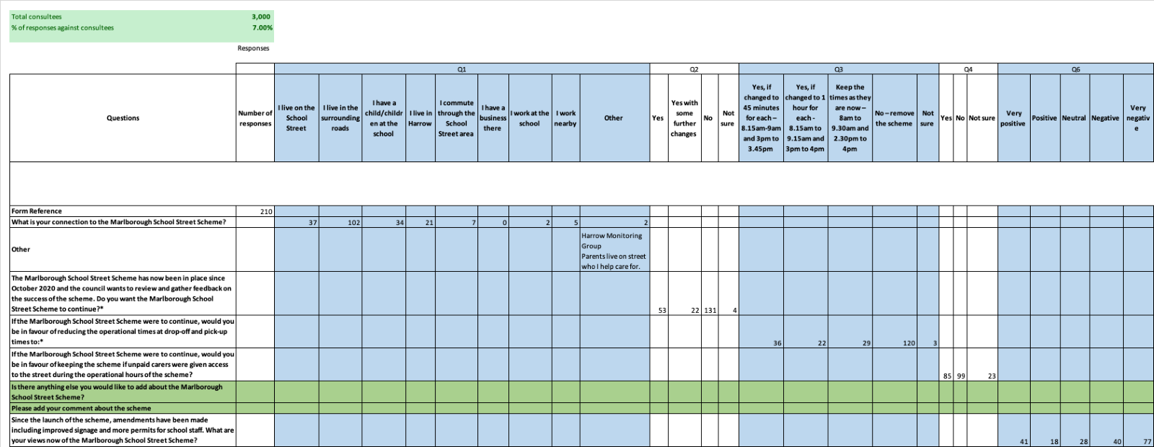
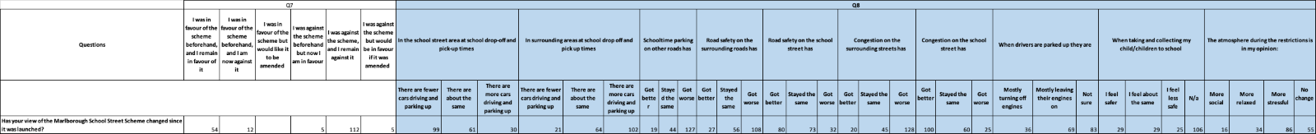
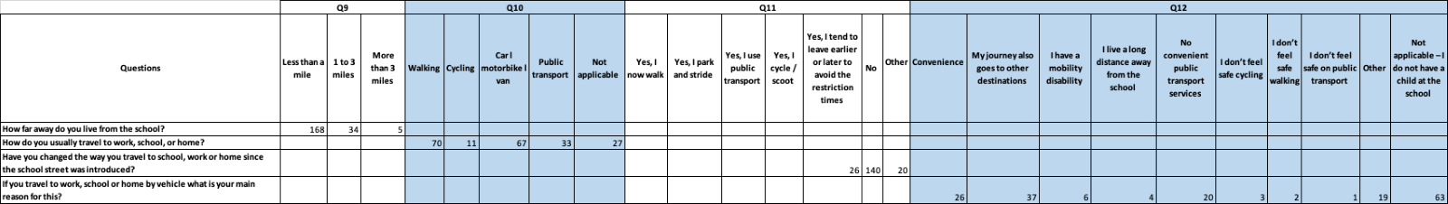

APPENDIX B

Marlborough School Street Scheme consultation July 2022

- What is your connection to Marlborough School Street Scheme?

a. I live on the School Street
b. I live in the surrounding roads
c. I have a child/children at the school
d. I live in Harrow
e. I commute through the School Street area
f. I have a business there
g. I work at the school
h. I work nearby
i. Other

- The Marlborough School Street Scheme has now been in place since October 2020 and the Council wants to review and gather feedback on the success of the scheme. Do you want/wish the Marlborough School Street Scheme to continue?

a) Yes
b) Yes, with some further changes
c) No
d) Not sure

- The Marlborough School Street Scheme (suspended from 21 July) operates for 90 minutes during school term times only (drop-off, 8am-9.30am, and pick-up, 2.30pm-4pm). These times were chosen during lockdown when school start times were staggered.

If the Marlborough School Street were to continue; would you be in favour of keeping the scheme if the operational times were reduced at drop off and pick up times to:

a. Yes, if changed to 45 minutes for each – 8.15am-9am and 3pm to 3.45pm
b. Yes, if changed to 1 hour for each - 8.15am to 9.15am and 3pm to 4pm
c. Keep the times as they are now – 8am to 9.30am and 2.30pm to 4pm
d. No – remove the scheme
e. Not sure

- The Marlborough School Street Scheme restricts vehicle access to the school street during the busiest times of day. Additional vehicles added may mean more vehicles on the road during restrictions. A list of the vehicles allowed access to the school street during operational hours are available online at www.harrow.gov.uk/schoolstreets

If the Marlborough School Street Scheme were to continue; would you be in favour of keeping the scheme if unpaid carers were given access to the street during the operational hours of the scheme?

Please note: A carer is anyone, including children and adults, who look after a family member, partner or friend who needs help because of their illness, frailty, disability, a mental health problem or an addiction and cannot cope without their support. A person providing childcare, similar to that of a childminder - whether it’s a family member or a paid person/organisation, will not be eligible to apply.

a. Yes
b. No
c. Not sure

- Is there anything else you’d like to add about the scheme? (open field)

- Since the launch of the scheme, amendments have been made including improved signage and more permits for school staff. What are your views now of the School Street Scheme?

a. Very positive
b. Positive
c. Neutral
d. Negative
e. Very negative

- Has your view of the Marlborough School Street Scheme changed since it was launched?

- I was in favour of the scheme beforehand, and I remain in favour of it
- I was in favour of the scheme beforehand, and I am now against it
- I was in favour of the scheme but would like it to be amended
- I was against the scheme beforehand but now I am in favour
- I was against the scheme, and I remain against it
- I was against the scheme but would be in favour if it was amended

- Have you noticed any change in activities or behaviour around the school since the school street was introduced?

In the school street area at school drop-off and pick-up times

- There are fewer cars driving and parking up
- There are about the same
- There are more cars driving and parking up

In surrounding areas at school drop off and pick up times

- There are fewer cars driving and parking up
- There are about the same
- There are more cars driving and parking up

Schooltime parking on other roads has

- Got better
- Stayed the same
- Got worse

Road safety on the surrounding roads has

- Got better
- Stayed the same
- Got worse

Road safety on the school street has

- Got better
- Stayed the same
- Got worse

Congestion on the surrounding streets has

- Got better
- Stayed the same
- Got worse

Congestion on the school street has

- Got better
- Stayed the same
- Got worse

When drivers are parked up they are

- Mostly turning off engines
- Mostly leaving their engines on
- Not sure

When taking and collecting my child/children to school

- I feel safer
- I feel about the same
- I feel less safe
- N/a

The atmosphere during the restrictions is in my opinion:

- More social
- More relaxed
- More stressful
- No change

SECTION THREE TRAVEL HABITS

- How far away do you live from the school?

  - Less than a mile
  - 1 to 3 miles
  - More than 3 miles

- How do you usually travel to work, school, or home?

  - Walking
  - Cycling
  - Car l motorbike l van
  - Public transport
  - Not applicable

- Have you changed the way you travel to school, work or home since the school street was introduced?

  - Yes, I now walk
  - Yes, I park and stride
  - Yes, I use public transport
  - Yes, I cycle / scoot
  - Yes, I tend to leave earlier or later to avoid the restriction times
  - No
  - Other

- If you travel to work, school or home by vehicle what is your main reason for this?

- Convenience
- My journey also goes to other destinations
- I have a mobility disability
- I live a long distance away from the school
- No convenient public transport services
- I don’t feel safe cycling
- I don’t feel safe walking
- I don’t feel safe on public transport
- Other
- Not applicable – I do not have a child at the school

- Have you given us your feedback on the Marlborough School Street Scheme before?

- Yes, online consultation
- Yes, email
- Yes, paper survey / consultation
- Yes, other (please specify)
- No

Please share your email address with us if you would like to be updated on the outcome of this Marlborough School Street consultation:
Open text box

MONITORING QUESTIONS TO BE INSERTED – sent separately

THANK YOU

Thank you for taking time to take part in the Marlborough School Street consultation. The consultation closes on 25 September and a decision will be made by the Council following the outcomes of this consultation being considered by the Traffic and Road Safety Advisory Panel (TARSAP) on 18 October.

The Marlborough School Street Scheme will remain suspended from the end of the school summer term (21 July) until a decision on its future is made in October. If you live within the consultation area or have included your email address, we will let you know about the outcome and future of the scheme following the decision on its future.

